

Version: 3.0

Buildings Permits System

Business Requirements Specification

Dubai Municipality

Information Technology Department

# Statement of Confidentiality

This document and all associated attachments mentioned therein are the intellectual property of DM. This document shall be used only by persons authorized by DM, for the purpose of carrying out their obligations under a specific contract with DM. Unauthorized copying, printing, disclosure to third party and transmission of this document to any other destination by any media will constitute an unlawful act, attracting appropriate

All information presented in this document or shared with the addressee, as part of the proposing process is considered strictly confidential. As such, the addressee should not disclose this document or any attachments in whole, or in part to any third party without the prior written consent of Dubai Municipality (DM).

The addressee also acknowledges that information shared here within is the intellectual property of Dubai Municipality and is subject to a disclosure agreement as recognized by the copyright and intellectual property protection regulations.

# Copyright Information

Copyright © DM, 2020

This document and all associated attachments mentioned therein are the intellectual property of DM. This document shall be used only by persons authorized by DM, for the purpose of carrying out their obligations under a specific contract with DM. Unauthorized copying, printing, disclosure to third party and transmission of this document to any other destination by any media will constitute an unlawful act, attracting appropriate legal actions.

# Control Document Notification

This is a controlled document. Unauthorized access, copying, replication and usage for a purpose other than for which this is intended are prohibited.

This document is being maintained on electronic media. Any hard copies of it are uncontrolled and may not be the latest version. Ascertain the latest version from the Document Master List available with ISOFT Emirates Project Manager.

Document Control Sheet

|  |  |  |  |  |  |
| --- | --- | --- | --- | --- | --- |
| Document Information | | | | | |
| **Document Title:** | | Business Requirements Specification | | | |
| **Owner:** | | DM | | | |
| **Document Reference:** | | BRS | | | |
| Document Change History | | | | | |
| **Version** | **Date** | **Description of Change** | | | **Author** |
| 1.0 | 09 Mar 2020 | Document Initiation | | | Isoft |
| 1.1 | 30 May 2020 | Service Details | | | Hani Imran |
| 1.1 | 30 May 2020 | Service Details | | | Assmaa Hussien |
| 1.1 | 30 May 2020 | Service Details | | | Mohamed Elshourbagy |
| 1.1 | 30 May 2020 | Service Details | | | Ahmed Hashem |
| 1.1 | 30 May 2020 | Service Details | | | Omnia Mostafa |
| 1.1 | 30 May 2020 | Service Details | | | Mai Rashed |
| 1.1 | 22 Jun 2020 | Review | | | Hani Imran |
| 1.1 | 24 Jun 2020 | Review | | | Assmaa Hussien |
| 1.2 | 26 Jun 2020 | Update Service Details | | | Mohamed Elshourbagy |
| 1.2 | 26 Jun 2020 | Update Service Details | | | Ahmed Hashem |
| 1.2 | 26 Jun 2020 | Update Service Details | | | Omnia Mostafa |
| 1.2 | 26 Jun 2020 | Update Service Details | | | Mai Rashed |
| 1.3 | 29 Jun 2020 | Review | | | Maha Gabr |
| 1.4 | 30 Jun 2020 | QA Review | | | Eman Alayyat |
| 1.5 | 31 Aug 2020 | Divide BRS into two files one for each department  Update business owners feedback based on Meeting A | | | Omnia Mostafa |
| 1.6 | 01 Sep 2020 | Review Updates | | | Assmaa Hussein |
| 1.7 | 09 Sep 2020 | Update business owners feedback based on Meeting B | | | Omnia Mostafa |
| 1.8 | 10 Sep 2020 | Review Updates | | | Assmaa Hussein |
| 1.9 | 17 Sep 2020 | Update business owners feedback based on Meeting C | | | Omnia Mostafa |
| 2.0 | 20 Sep 2020 | Review Updates | | | Assmaa Hussein |
| 2.1 | 28 Sep 2020 | Update as per business feedback | | | Omnia Mostafa |
| 2.2 | 01 Oct 2020 | Update BRS with Survey results | | | Omnia Mostafa |
| 2.3 | 05 Oct 2020 | Review updates | | | Assmaa Hussein |
| 2.4 | 06 Oct 2020 | Review highlighted sections | | | Maha Osama |
| Document Sign Off | | | | | |
| **Version** | **Date** | **Person** | **Role** | **Comments** | |
| 1.0 | 24 Jun 2020 | Assmaa Hussein | Product Manager |  | |
| 2.0 | 17 Sep 2020 | Assmaa Hussein | Product Manager |  | |
| 3.0 | 07 Oct 2020 | Assmaa Hussein | Product Manager |  | |
| 4.0 | 14 Oct 2020 | Assmaa Hussein | Product Manager |  | |

**Table of Contents**

1 Introduction 6

1.1 Document Purpose 6

1.2 Intended Audience 6

1.3 Scope 6

2 Business Process Overview 8

2.1 Proposed Business Process 8

GEO Consolidated Information Hub 8

Business Domain Model 10

Smart Modules 13

2.2 Smart Modules 14

User Management 14

Customer Management 14

Staff Management 14

Dynamic Dashboard 15

KPIs Evaluation & Monitoring 15

Web Analytics 17

Business Intelligence 17

E-Checking 17

BIM 18

Notification & Communication 19

Appointments Module 19

Chatbot 20

Scheduler Management 20

Employees Allocation and Utilization 20

Staff Availability Monitoring 21

Task Management 21

Dues Management 21

Digital Process Automation 22

Dynamic Business Rule Engine 22

Audit Trail 23

Services’ SLA 23

Reporting Utility 23

2.3 Permit Services 24

2.3.1 Core Components 26

Land Card 26

Project Profile 27

Fast Track Inquiry 31

2.3.2 Core Services 32

Building Permit 32

Concept Design Approval 37

2.3.3 Supporting Services 40

Building Exception 40

Land Procedures 46

3 Dependencies 50

4 Risks 51

5 Assumption 52

6 Appendices 53

6.1 References 53

6.2 Survey Result 0

# Introduction

## Document Purpose

The purpose of this document is to describe the business specifications of an Application completely, accurately, and unambiguously in a Technology-independent manner. All attempts have been made to use business terminology and business language mostly while describing the solution in this document. Very minimal and commonly used Technical terminology has been used. Use case / Designer approach is used in modeling the business specifications in this document.

## Intended Audience

The main intended audience for this document is the business owners of the Building Permit and Control system. This document should be readable by business owners of the proposed system. They shall be able to verify that their business specifications have been documented here completely, accurately, and explicitly.

Data Architects, Application Architects, and Technical Architects shall also find the information in this document useful when there is a need to verify the solution to address these business specifications.

Since the specifications are documented here in Technology-independent manner, the end-users of the system should be able to comprehend the features fairly and easily from this document.

## Scope

This year, Dubai Municipality has achieved remarkable success in obtaining the first position in the Arab region, and the third worldwide in the ease of obtaining Building Permits until its completion, according to the International Bank's assessment and annual study conducted under the title « **Business Practice in the World**».

This success was the result of an unusual effort by the **Dubai Building Licensing Committee's** teamwork, comprising government departments, and licensing agencies, which canceled and merged many of the previously required steps, as the application process was consolidated through the unified form instead. This has resulted in significant progress over the past few years based on International Bank evaluation criteria, which includes the number of licensing steps, fees, duration, and quality.

Therefore, we built a comprehensive strategy to enhance Building Permit and Control procedures, raised the level of customer satisfaction, and provided distinguished services to create a competitive investment environment in the Emirate of Dubai. This is where we started to develop a new vision for the Building Permits and Control based on Building Information Modeling and Geographic Information systems, which is the latest global mechanism in design buildings and their oversight. Accordingly, this contributes to shortening time and effort, raising the level of quality of the building permit and control, as well as helps to provide comprehensive and detailed 3D maps of Dubai to support the provision of smart city services.

# Business Process Overview

## Proposed Business Process

##### GEO Consolidated Information Hub

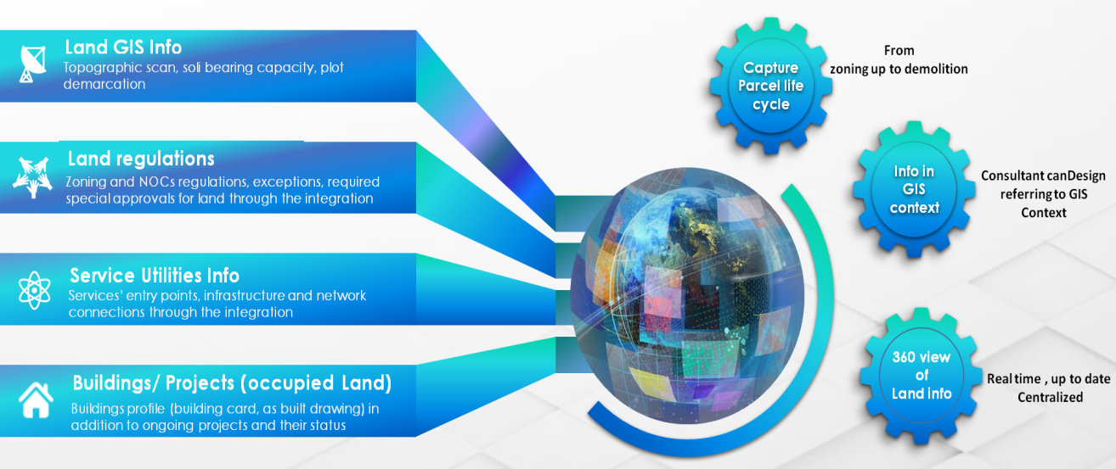

**GEO Consolidated Hub**

Regarding the new business process proposed, we introduce the *#GEO Consolidated Hub* which will be constructed through the integration between GIS and internal and external authorities.

The *#GEO Consolidated Hub* demonstrates:

* Parcel life cycle from zoning up to demolition.
* Increase Drawings’ accuracy using GIS context.
* 360 view on real time, up-to-date and centralized information.
* Integration with 24 internal /external departments and authorities.

1. **External**

* Land Department ***New***
* Real Estate Regulatory Authority ***New***
* Department of Economic Development ***Modified***
* Dubai Electricity and Water Authority ***Modified***
* Dubai Civil Defense ***Modified***
* Dubai Civil Aviation Authority ***Modified***
* Roads and Transport Authority ***Modified***
* Department of Tourism and Commerce Marketing ***Modified***
* Emirates Integrated Telecommunications Company [Etisalat /DU] ***Modified***
* Dubai Naturalization and Residence Department ***Modified***
* UAE Pass ***New***

1. **Internal**

* Planning Department ***New***
* Demarcation Survey Department ***New***
* Drainage Project Department ***New***
* Environment Department ***Modified***
* Architectural Heritage and Antiquities Department ***New***
* Consultants and Contractors Prequalification section ***Modified***
* Finance Department ***Modified***
* IT Department (Archive system, Active Directory, GRP, SMS/Email Gateway) ***New***

##### Business Domain Model

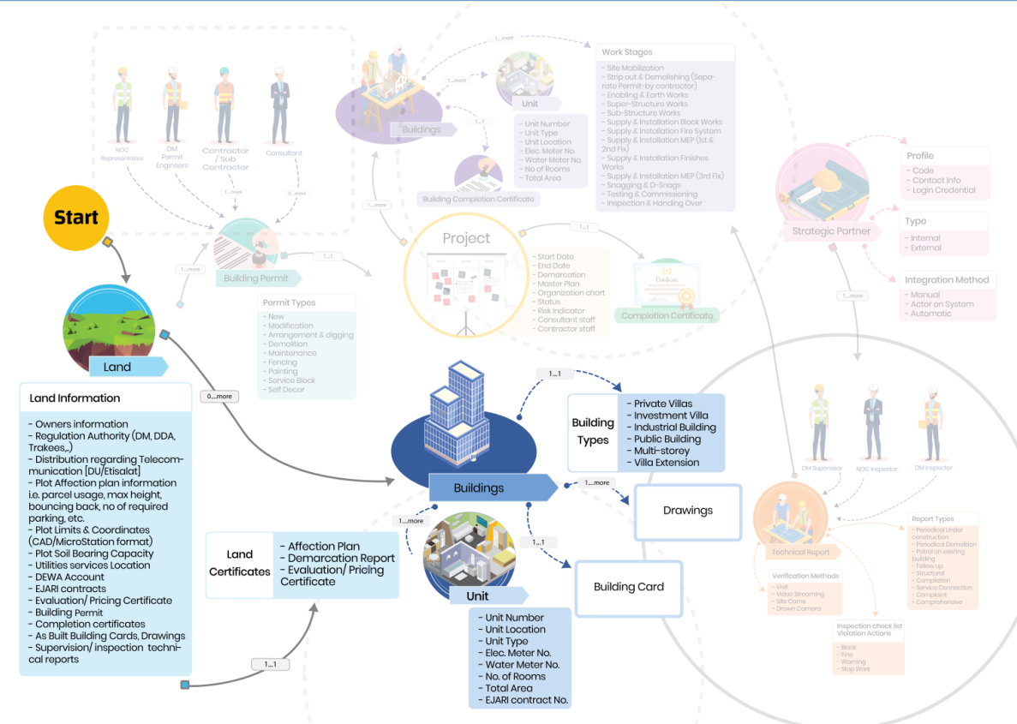

**Domain Model – Self-assignment to Land**

Through applicant’s dashboard, the land can be searched for and selected for assignment without additional step from Landowner(s) using *#GEO Consolidated Hub* presented in the map.

* Based on Self-assignment, no appointment documents or actions required from Landowner(s).
* Self-assignment will not be accomplished unless the applicant accepts legal Terms and Conditions.
* The applicant will be authorized only to apply for Lands/Permit types that match his/her qualification and specialty based on *#integration* with pre-qualification section. Landowner(s) will be notified according to self-assignment actions, in case there is any objection, Landowner(s) can easily block the applicant from accessing the land through their dashboard, and the Applicant KPIs will be impacted by this objection.

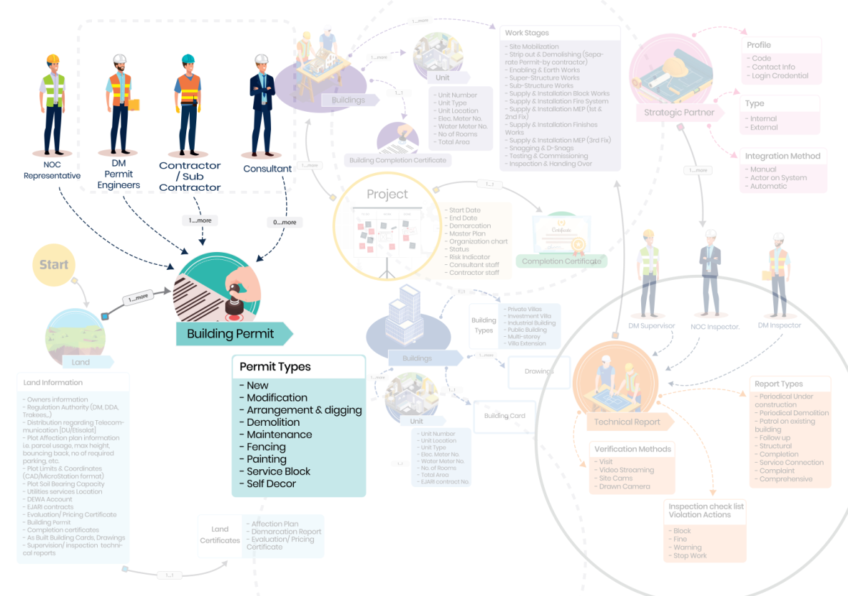

**Domain Model – Building Permit**

On Land, assigned applicants will be able to apply for building permit through unified service with no entries or documents. Moreover, applicants will benefit from various indicatives components in permitting stage such as:

* Fast Track Inquiry: provide the ability to inquire as applicant from DM and also from other authorities during preparation stage *(optional)*
* Concept Design Approval: Approval for initial design *(optional)*
* Drawing Unification and versioning: for both CAD and BIM models
* Auto generated Building Card extracted from uploaded Drawings
* E-checking on uploaded drawings (CAD or BIM) against DM regulation based on building type, usage and permit type as a first level of verification on submission level
* Human expertise verification as a second level of verification by DM engineers and NOC’s representatives after permit submission, according to configuration.

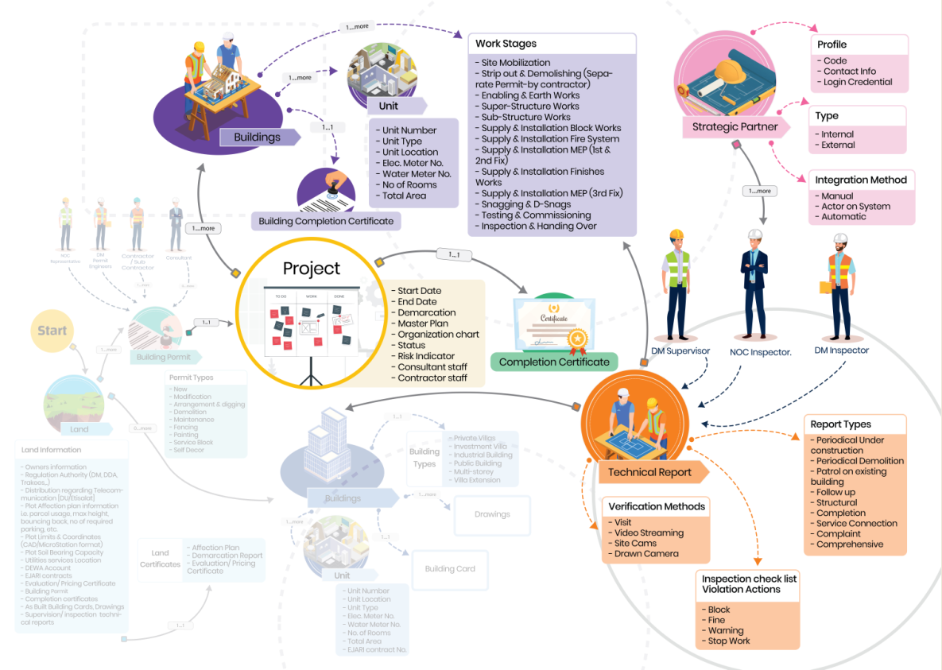

**Domain Model – Project Inspection & completion**

Once the permit is issued, the Project will be initiated accordingly exploring the information of plan, staff, activities, scope, risks, and accountability.

Applicants will also have the facility of incremental completion for each building separately, or full completion for the whole project with cooperation of our strategic partners (internal/external authorities). This cooperation is performed through configurable inspection checklist based on building type, usage and work stages using the technology trends in the field of building inspection.

##### Smart Modules

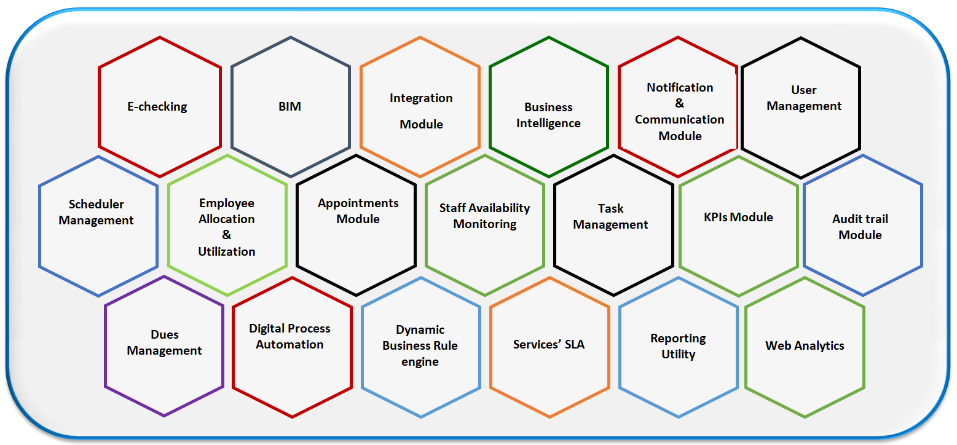

**Smart modules domain model**

Besides, an additional 19 smart modules supporting the proposed process automation as listed below:

1. E-checking Engine
2. BIM Engine
3. Integration Module
4. Business Intelligence
5. Notification & Communication
6. User Management
7. Scheduler Management
8. Employees allocation and utilization
9. Appointments Module
10. Staff Availability Monitoring
11. Task Management
12. KPIs Evaluation & Monitoring
13. Audit trail
14. Dues Management
15. Digital process Automation
16. Dynamic Business rule engine
17. Services’ SLA
18. Reporting Utility
19. Web Analytics

## Smart Modules

##### User Management

###### Customer Management

* Seamless on boarding using UAE Pass based on Customer type (Owner, Consultant, Contractor, Secondary contractor, Individual) all customers will login to the system in no time without the need for Separate Username and Password
* By Integrating with DEQ, the consultants, contractors and secondary contractors will be able to view their technical staff profiles.
* Every Consultant office or Construction company will be responsible for making quick on boarding to their Staff without any involvement from the DM engineers.
* This will allow electronic assignments to the Technical engineers on the running projects and will allow quick and easy steps for Consultant, Contractor and Secondary contractor to set the responsibility for each Staff Member.

###### Staff Management

* Seamless onboarding using integration with active directory and GRP to handle staff login DM staff, government authorities and NOC’s Staff, and keep up to date for any transformation to the staff members from Department/Unit to another, as these information will be updated in the Active Directory and GRP system, and will be automatically reflected to the system with no need to make any updates.
* Each Staff will have privileges on the system according to his/her role, department and unit in the mapped-on organization structure.
* According to these privileges and roles of staff member, the system will be able to set up his/her Calendar according to the task estimated time, working hours, capacity, utilization, and availability.
* Admin will be able to set up the DM Staff Calendar including holidays.

###### Dynamic Dashboard

* This Feature will be available for both Customers (including individuals, Consultant’s admin, Consultant’s staff, Contractor’s admin, Contractor’s staff), and DM Staff members and NOCs representative.
* The Dashboard will be displayed as per the persona type, interests, and role.
* This includes Real-time statistics and charts that related to the persona active projects and needed information according to the current state.
* It will include life Geographic MAP for lands using GEO CONSOLIDATED HUB integration with Internal and External Authorities to display all needed information related to any parcel on the map. This will help the persona to search any parcel easily and display all related information.
* Urgent and Recommended actions based on the business intelligence and data analysis done by the system’s smart agent that analyzes the current persona type, status and the next action required from him/her in all his/her running projects, and automatically display it to allow persona take the actions on the spot. In case the next required actions from the customer doesn’t need any extra information from the customer, the system will submit it automatically on behalf of the customer, for example:
  + After finishing supervision on the last work stage on the current project, the system will automatically recommend or apply for Completion certificate.
  + Disconnect services request after demolition permit will be issued.

##### KPIs Evaluation & Monitoring

* Dynamic configuration of KPI as definition, weight, equation, and calculation method based on persona type.
* KPIs will handle strategic, operational, business stakeholders (consultant, contractor) and DM Staff evaluation as well,
  + Strategic KPIs of the Building Control Department
    - Compliance of under construction buildings
    - Compliance of existing buildings
  + Operation KPIs of the Building Control Department
    - Indicators of average number of construction safety accidents in Dubai (building under construction).
    - Indicators of average number of construction safety accidents in Dubai (Existing building)
    - Indicators of the percentage of delivering services to customer on time
    - Indicators of the frequency of entering the transaction because the customer did not comply with the application requirements.
    - Indicators of the percentage of sites that are inspected from the total buildings for both under construction & existing buildings
  + Business stakeholder's evaluation KPIs may capture and measure the below:
* Compliance with Renewal regulations
* Compliance according to Field audit
* Issued violations
* Compliance with rules and regulations
* Application version submission average and notes response
* Engineering Submission Quality
* Compliance with safety and security requirements on construction sites
* Compliance with building laws, regulations and legislation during the periodic inspection process
* The record is free of technical complaints related to construction work
* Compliance with the requirements to submit a structural audit and completion transaction
* Compliance and commitment with building laws, regulations and legislation during the periodical inspection process
* Compliance with the completion application requirement
  + Staff evaluation KPI’s may capture and measure the below:
* Compliance with section/unit goals
* Verification accuracy based on building laws and regulations taking into consideration the reason of repeated applications
* Actual capacity compared with configured ones on daily basis
* Customer evaluation for Staff after each appointment as per Customer Feedback
* On spot reports and statistics customizable according to Management, need using Reporting tool.
* The evaluation of the current business stakeholders and DM staff, and how they are aligned with the KPI’s related to their type role and responsibility will be handled according to scheduled / manual triggers.
* Scheduled and dynamic evaluation reports and statistics for Management monitoring.
* Achieve Transparency by publishing evaluation results with personas through their dashboard.
* At any time, persona can View his/her progress and evaluation according to the configured KPIs to improve themselves.
* Any Manager can see the alignment of his/her staff on the configured KPIs to be able to fix any problem facing them, and take the corrective actions needed if any.
* Motivational actions will be configured for high performance personas, for example recommend working in mega projects, or issue certificate of accreditation.

##### Web Analytics

* User Flow: Visual representation of the most popular paths your users followed through your website or app. Moreover, getting more insights by analyzing those paths and where along the path they exited your site.
* Content Tracking: Measure impressions, clicks, and CTR for image banners, text banners, and any elements on your pages.
* Site Search Analytics: Track searches done on your internal search engine.
* Site speed and page speed reports: Track how fast your website delivers content to your visitors.

##### Business Intelligence

* Analyze existing and historical data, and trigger recommended actions to relevant persona type and role, i.e. the system can notify the DM engineer with the most common mistakes occurring by a specific consultant/engineer during:
  + The permit submission of a specific permit type and building type.
  + The periodical inspection over under construction buildings
* Moreover, based on the configured business rules, the system can direct the consultant to assign the contractor after the permit is issued.

##### E-Checking

* According to Land, status whether it is an empty or an occupied land, approved /as built drawings will be verified.
* Case of occupied Land, drawings version will be verified to apply unification.
* Based on the type of latest approved or as built drawings (CAD or BIM), uploaded drawings will be verified to validate the drawings version and standards.
* The system will extract the building information automatically from the uploaded drawings and map the extracted information with the saved Building Card details schema.
* Parking and Garbage area will be calculated automatically from system based on configured equations and these calculations will be used by E-checking engine in order to validate drawings automatically according to configured checklists.
* Automatic generation for Building Card from drawings based on DM approved standards for building classified object and design guidelines (Layers) for both CAD and BIM Models.
* Automatic verification on Drawings using configured checklists based on building types, usage and permit type will be run on the generated Building Cards.
* The output of E-Checking module will be:
  + The automatic Generated Building Card
  + The E- checking verification result with clear and detailed error messages. In case of errors, identify what is the error and in which drawing file.

Note that both extracted information and verified checklist will be configured for each service type, building type, and building usage.

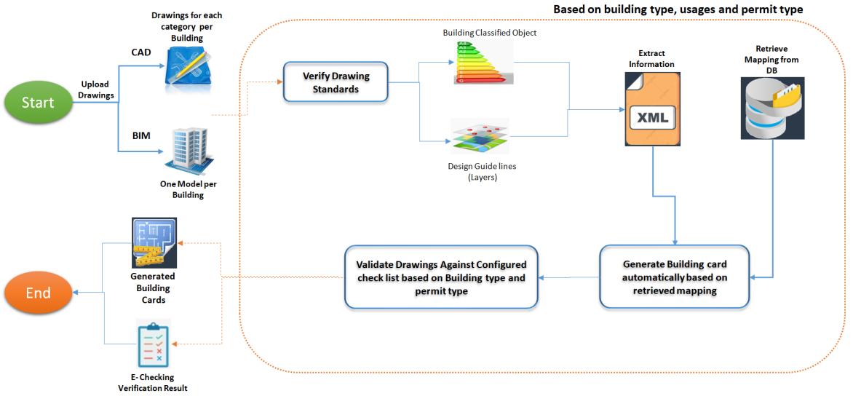

**E-checking Process Flow**

##### BIM

* Integration with BIM Drawings Type to Extract Information by E- checking
* Integration with BIM Drawings to view Drawings and Add Comments on verification to be saved on the Drawings directly.
* Track all comments added on drawings and verify any changes done on Drawings
* BIM integration with GIS information (such as the municipality’s city plans, topographical maps and digital elevation models).
* Analytical and Visual Rule Checking using information that can be extracted from BIM models.

##### Notification & Communication

* This module facilitates communication among different users to maintain workflow and maximize productivity.
* It allows broadcasting messages to users automatically and effectively.
* Highly configurable engine that can handle sending/receiving different types of messages on various events and situations globally or to specific groups/Individuals through available channels such as emails or SMSs to consider costs as well.
* Handle both Arabic and English languages for notification text.
* The Notification will include three types:
  + Services Notification
    - Handle configuration of all services actions that need notifications
    - Handle configuration of users to be notified according to defined responsibility Matrix of each service
    - Ability to seclude periodical notification to be sent in configured periods
  + Circular Notification
    - Ability to handle Circular notifications for DM staff, Customers, or both of them
  + Surveys
    - Design the surveys to be sent to both DM staff and Customers.

##### Appointments Module

* Responsible for defining the appointments between DM engineer and Applicant (Owner, Consultant, Contractor, Secondary Contractor) to discuss/clarify remarks, permit application details, drawings, violations and any remarks raised while project stages and activities of Buildings control (Inspection, Supervision).
* Module start with define the Appointment configuration to be used by applicant while Request appointment with DM engineer.
* Applicant will be able to request, reschedule, and cancel appointments.
* The system will display the applicants’ appointments with the ability to filter and sort them according to their interest.
* The system will display the DM staff appointments with the ability to filter and sort them according to their interest.
* The system will send notification to Applicant and DM engineers with configured actions of Appointments.
* The system will integrate with appointment tool that will record the meeting along with exchanged files during the meeting.

##### Chatbot

* Chatbots are responsible for answering basic customer questions via business messenger. Chatbots use the existing information and resources, like FAQs or knowledge base articles, to help answer and resolve customers’ questions.
* Chatbots will present instance response on the customers’ enquiries without involving the customer support engineer for the FAQ questions and saved topics.
* Chatbots will be able to redirect the customer question to the customer support in case the customer asks new questions, or the question needs extra details.
* Chatbots can be trained to add questions and answers to handle most of customer’s enquiries.

##### Scheduler Management

* Configure the slots according to the defined staff working hours.
* Automatic plan DM staff Schedule according to the staff department, unit, role, and responsibilities.
* Generate the available time slots for DM engineers to enable them to execute the appointments and tasks.
* Manage task reschedule and task transfer.
* Manage scheduled notifications.

##### Employees Allocation and Utilization

* Keep track of all tasks assigned to the DM engineers and monitor their utilization.
* Monitor Actual Time allocated to projects versus the plan percent.
* Measure how much employees are utilized and whether they are under or over allocated to projects.
* Maximize the use of resources time.

##### Staff Availability Monitoring

* Track the DM engineer leaves, permission, and vacations.
* Track the availability of NOCs’ representatives to form the completion committee for example.
* Help the task management to handle tasks and appointment according to the staff availability

##### Task Management

* Task Planning.
* Task Rotation.
* Task Assignment/Transfer by the DM engineer or his/her direct supervisor.
* Task Acceptance or Notification.
* Task Scheduling/Rescheduling by the DM engineer or his/her direct supervisor.
* Appointment Scheduling/Rescheduling.
* Configuration of the Recurring Tasks.
* Handle tasks Priority.
* Task Tracking: Trace exactly which activities are started, in progress and completed.
* Calendar Syncing: Easily integrated with a simplified calendar that is easy to manage and access through a calendar.
* Configured to organizing and scheduling tasks as well as using it to work for project timelines and meetings.
* Time Tracking: Keep track of the time for each activity

##### Dues Management

* Build fees and fines structure.
* Configure and calculate services’ fees.
* Handle insurance deposits and refunds.
* Integrate with DM payment gateways, real-time evaluation along with motivated actions.
* Calculate the Permit application charges according to the Configured rules on application Submission.
* Calculate the Permit Charges and Deposit amount after Application approval.
* Generate all payment details related to charges and permit deposit amount.

##### Digital Process Automation

* Easy Modeling of Processes and Forms.
* Enterprise Architecture Modeling.
* Data Capture, Management, and Analysis.
* Social Collaboration Features.
* Enterprises are discovering the utility of social collaboration. From document sharing to discussions to approval cycles, BPM system will allow social collaboration in context of your business activities, with a friendly interface that is familiar to users.
* Real-Time Monitoring and KPI Measurement.
* BPMN 2.0 Support.
* Adaptive Case Management (custom workflows).
* Responsible for handling services workflow and automatically forking to send the tasks’ steps to the assigned Staff / NOC’s representatives automatically according to the configurations.

##### Dynamic Business Rule Engine

* Enables the DM policies and other operational decisions to be defined, tested, executed and maintained separately from application code.
* Typically support rules, facts, priority (score), mutual exclusion, preconditions, and other functions.
* Accessible, semantically rich, and declarative rule syntax.
* A repository to store, version, manage, and audit rules.
* Tools for testing, validating, verifying, and simulating rules and rule changes.
* Deployment capabilities to package up rules and put them into a decision service.

##### Audit Trail

* Tracks changes and actions in the system.
* Assists in maintaining transparency, accountability and integrity in between DM and Customers.
* Provides documentary evidence of the activities sequence that might have affected a specific operation, procedure, or event log at any time.

##### Services’ SLA

* Configure and monitor the SLA’s Structure, Setup and runtime.
* Will be used to track the Staff evaluation and define the KPI’s related to services.
* Will be monitored to be able to improve the customer satisfaction on all the presented services by DM.
* Track services performance against Configured SLA.

##### Reporting Utility

* Interactive reports.
* Ad hoc reports.
* Rich presentation and report layout library.
* Data mash-up across multi-source data objects.
* Aggregating, grouping, and filtering.
* Viewing Real-time or queued reports.
* Export to Excel, PowerPoint, PDF, RTF-Word, CSV, PostScript, Text, and SVG.
* In-report sorting, filtering, hide/unhide.
* Enable data visualization, customization, and formulas.
* Generate scheduled reports and auto-share.
* Built-in analytics and dashboards.
* Display Reports per search criteria, Custom Reporting Software.

## Permit Services

Introducing a new approach of issuing **Immediate Building Permit** through unified window with no entries, no documents, and handling CAD and BIM drawings based on E-checking according to building type, usage, as well as permit type, which increase the alignment with the World Bank indicators of international competitiveness.

This approach depends on empowering preparation stage with all Land information, zoning regulations, NOC authorities’ guidelines, Land construction status, and then come up with a smooth approach of permit submission and issuance, based on automated checklists configured according to building type, usage, and permit type.

This approach proposes services restructuring through introducing only 3 new services rather than the current 25 services. These services are as follows:

Core services:

1. Building Permit
2. Concept Design Approval (Optional)

Supplementary Service:

1. Building Exception

These services are powered by the below core components:

* Land Card
* Project profile initiation
* Fast Track Inquiry (optional)

|  |  |  |
| --- | --- | --- |
| **#** | **Current Services** | **New Services** |
| **Core services** | | |
| 1 | Preliminary - New Building | Concept Design Approval |
| 2 | Preliminary - Adjustment/Addition |
| 3 | Preliminary - Arrangement and digging(to be Deleted) |
| 4 | Final New Building | Building Permit |
| 5 | Final Arrangement and Digging |
| 6 | Final Adjustment/Addition |
| 7 | Simple Adjustment/Addition |
| 8 | Building Demolition |
| 9 | Fencing |
| 10 | Self-Décor |
| 11 | Painting |
| 12 | Maintenance |
| 13 | Service Block |
| **Supplementary Services** | | |
| 14 | Building Exception | Building Exception |
| **Current Service** | | **Future Digital Procedure** |
| 15 | Application Cancellation | Action on applicant dashboard |
| 16 | Request copy of approved drawings | Provided in Land Card component  (click) |
| 17 | Extending Drawings Approval Validity |
| 18 | Soil Report Request |
| 19 | Gate Level |
| 20 | Request to approve a new building System | Integration through *#GEO Consolidated Hub* |
| 21 | Request to Increase Electricity Load | Recommended to be shifted to DEWA and information can be exchanged through *#GEO Consolidated Hub* |
| 22 | Request Additional Meters |
| 23 | Roof signboards | Recommended to be shifted to advertisement Department and information can be exchanged through *#GEO Consolidated Hub* |
| 24 | Road signboards |
| 25 | Land Procedures | Land procedures  (Automated) |

This approach will be applied using below Concepts and methodologies:

* Introducing GEO Consolidated Hub Concept: Provide all Land information from internal/ external authorities.
* Configurable on spot inquiry from authorities: Based on building types, usage, and permit type.
* Provide services with no entries, no documents uploading – only Drawings.
* Introduce Drawing Unification and Versioning: Concept on building level, based on Block chain.
* E - Checking on Drawings using configurable checklists: Based on building types, usage, and permit type.
* Automatic generation for Building Card from drawings: Based on standard templates CAD and BIM.
* Immediate Permit issuance-based E-checking: building types, such as Villas and industrial buildings.
* Introduce automation of Land Split & Merge procedures: Based on Plot coordinates and unified Building Cards.
* Self - Assignment for consultants and contractors on Land: based on permit type and project coordinates to consider mega projects.
* Provide full integration with internal and external partners to enable paperless transactions.

### Core Components

##### Land Card

* Solution Brief

Introduce Land centralized information hub to explore all land information, based on integration between **Geo consolidated hub** and internal/external authorities.

* Actors

This component will be accessible for any applicant assigned on Land.

* Product

Land Information Hub.

* Prerequisites

Self -assignment to Land.

* Channels

New Customer portal.

* Solution Details

The aim of this component is to provide all land information that the applicant needs in a unified window, to get prepared and apply for their building permit using *#Integration*.

This information will be gathered from all internal/ external authorities and centralized in Geo Consolidated Hub. This also will fulfill the idea of building centralized database for all Lands regulated by Dubai Municipality.

Land card consists of the below sections:

* Land Summary: Affection Plan Details, Makani Link, and Land drawing.
* Land Details: Zoning regulation including soil bearing capacity, topographic scan and plot demarcation in CAD or MicroStation format.
* Land Exceptions: Any exception raised for this land – whether general or for specific building – along with its status.
* Land Utilities and Services: Services entry points, drawings, and regulations guidelines.
* Land Buildings: As built land card, drawings, and related ongoing projects.

##### Project Profile

* Solution Brief

This component represents the project information and the permit type proposed by the assigned applicant.

* Actors

This component will be accessible for any applicant assigned on land.

* Product

Saved project profile defined for the assigned land.

* Prerequisites

Self -Assignment to Land.

* Channels

New Customer portal

* Solution Details

The aim of this component is to define the project information and the permit type that the applicant is willing to apply for this Land in a unified window in order to get prepared and apply for their building permit.

As applicant, you should identify the below information using this component as a prerequisite before applying for any service:

* **Project Information**
  + Project Name
  + Project Description
  + Project Start/End Date
  + Project Related To
  + Developer Name
  + Drawing Type that will be automatically regulated by the system based on the Land status and configuration related to permit type, building type, and usage.
* **Option 1 : Permit Information**

Before applying for building permit service, the applicant should fill the below information:

**Permit Type:**

| **Type** | **Related Information** |
| --- | --- |
| New Building | * Drainage Department: Does Drainage department serve the plot? Served, Not Served, Not Applicable. * Is there shoring work from (ROW / Street / Sikka / Public Parking / Rail / Tram) side? Yes or No |
| Fencing | Identify Fence Type:   * Permanent * Temporary |
| Arrangements and Digging | Identify Arrange and Digging Type:   * Excavation shoring and dewatering, * Site Preparation and excavation and dewatering, * Piling Works & foundations, * Piling and Shoring works foundations, * Foundations |
| Modification | Identify category of modification per building:   * Modification (can be Minor, Medium, Major, or Complete Design) * Maintenance * Painting (can be Internal, External, or both) * Self-Décor |
| Demolition | Identify buildings in scope of demolition |

According to uploaded drawings during permit submission, the system will detect the below information, which is handled manually in the current system:

* + Additional House Connection {Yes, No, number of connections if Yes}
  + Does the modification works affect the shoring work {Yes, No}
  + Does the modification works involve external paving/access {Yes, No}
  + Does the modification works affect the temporary fence/entrance location {Yes, No}
  + Usage changes.
* **Building Information**

**Building Type:**

* + Private Villa,
  + Investment Villa,
  + Industrial building,
  + Public building,
  + Multistory,
  + Building service blocks.

|  |  |  |
| --- | --- | --- |
| **Building Usages** | | |
| * Offices | * Banks | * Residential |
| * Employees/Students Accommodation | * Commercial | * Shopping Center |
| * Cinema | * Theatre | * Hotel Apartment |
| * Hotels | * Indoor Services | * Outdoor Services |
| * Mosques | * Education | * Hospitals |
| * Warehouse/Factory/Workshop | * Petrol Station/Car Services | * Labor Accommodation |

In case the Building type is Building service blocks, the applicant should select one of these options:

* **Use DM Ready Designs**: Choose from predefined List of DM templates.
* **Use Applicant Designs**: Upload design within permit submission.
* **Request DM Staff to Design**: DM staff will design drawings on behalf of the applicant after site visit.

**In case of Exception required**

Before applying for Exception whether separately or within building permit application, the applicant should fill the below information:

* + **Exception Type, which will be selected from configured exception,** types list.
  + **Exception Sub Type**, which will be populated according to the selected Exception type.
  + **Exception Description**
  + **Related Buildings**, which will be selected from populated land buildings, list (if any).
  + **Area benefitted as a result of the exception**
  + **Expected meter square cost (AED)** which will be calculated by *#Dues Management* based on configured calculation methods.
* **Option 2: Concept Design Approval Type:**

Before applying for Concept design Approval service, the applicant should fill the below information:

| **Type** | **Related Information** |
| --- | --- |
| New Building | N/A |
| Arrangements and Digging | Identify Arrange and Digging Type:   * Excavation shoring and dewatering, * Site Preparation and excavation and dewatering, * Piling Works & foundations, * Piling and Shoring works foundations, * Foundations |
| Modification | Identify Modification Type:   * Minor * Medium * Major |

In addition to specifying the related building type and usages.

##### Fast Track Inquiry

* Solution Brief

Introduce on spot inquiry (optional tool) to explore the alignment between applicant design idea and DM/NOC authorities’ regulations, based on the integration between Geo Consolidated Hub and internal/external Authorities.

* Actors

This component will be accessible for any applicant assigned on land.

* Product

Consolidated NOC’s reply for the requested information

* Prerequisites

Self - Assignment to Land.

* Channels

New Customer portal.

* Solution Details

Using this tool, applicant will be able to inquire immediately – to concerned authorities based on configuration approved from DM – regarding authorities whom should be engaged in permit process, according to *#Digital Process Automation* based on building type and usage, also the integration between Geo consolidated hub and internal or external authorities using *#Integration*.

### Core Services

##### Building Permit

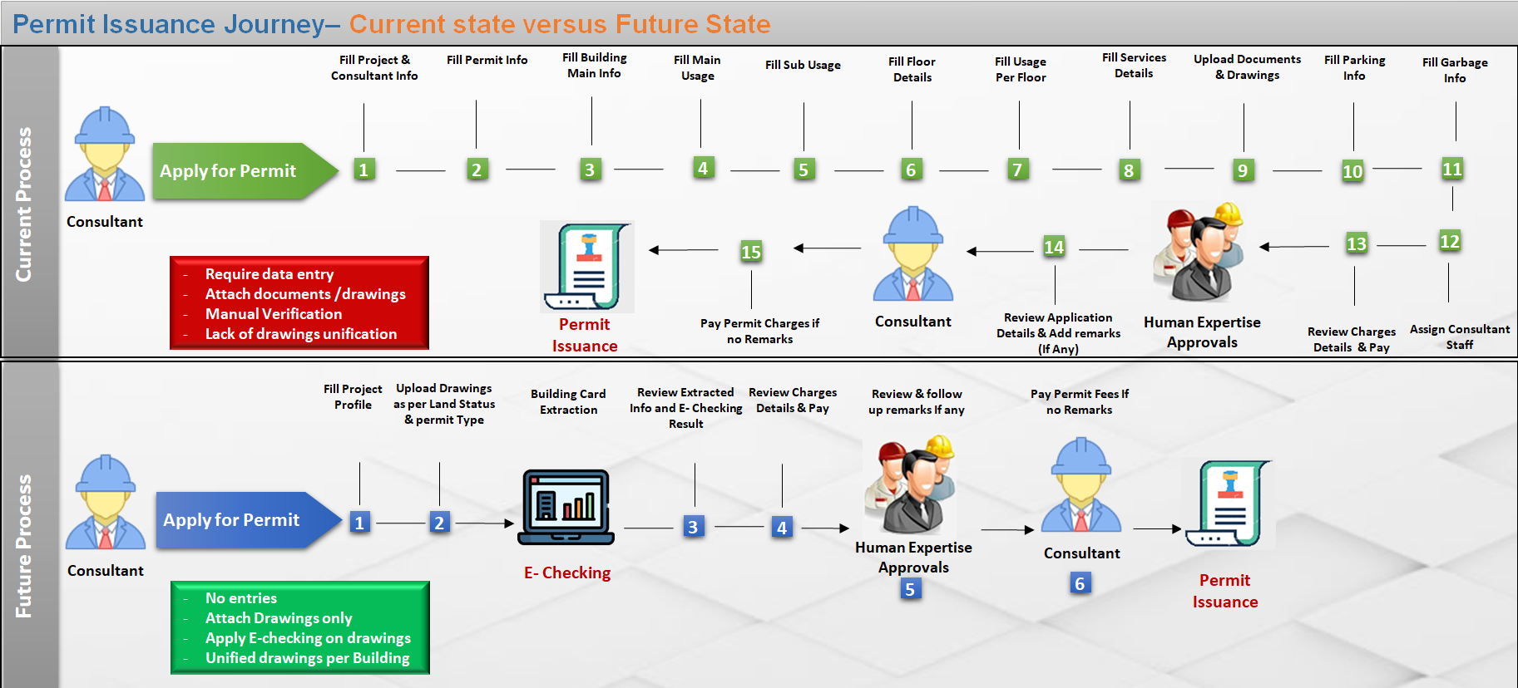

**Permit Issuance Journey– Current state versus Future State**

* Solution Brief

Introducing unified service to obtain building permit without entries or documents, just upload drawings in few steps. In addition to *#E-checking* verification for uploaded drawings on submission level, through configurable checklists based on permit type, building types, and usages to increase alignment with DM regulations.

As zone regulation specifies allowed usages for buildings, also Land status specifies type of drawings and allowed permit types for this Land:

**Case Empty land:** Applicant will have the flexibility to upload CAD or BIM drawings and to apply for the below permit types:

* Fencing
* Arrangement and digging
* New Building which include both above.

**Case Occupied Land:** Applicant will have to follow same type of **As Built** drawing, and can apply for the below permit types:

* Modification
* Demolition

Across various building types:

* Private Villa,
* Investment Villa,
* Industrial building,
* Public building,
* Multistory,
* Building service blocks.
* Actors
* Applicant (Consultant, Contractor or Owner)
* Smart Agent (System)
* Human Expertise (configurable whether internal or external Engineers)
* Product
* Active Building Permit Valid for 6 months
* Electronic Stamped and Approved Building Drawings
* Unified Building Cards/Drawings per Building.
* Prerequisites
* Applicant Self Assignment to the Land with acceptance to the Terms and conditions of assignment
* Design Drawings according to the approved standards by DM and using building classified object in addition to the design guide lines (layers) for each building.
* Fill project profile with the permit type , building type and usages
* Terms and conditions

Applicant will not be able to start work on site unless the below conditions are fulfilled:

* Insurance deposit paid by the assigned contractor
* Demarcation visit clearance.
* Channels

New Customer portal / New Employee portal.

* Solution Details

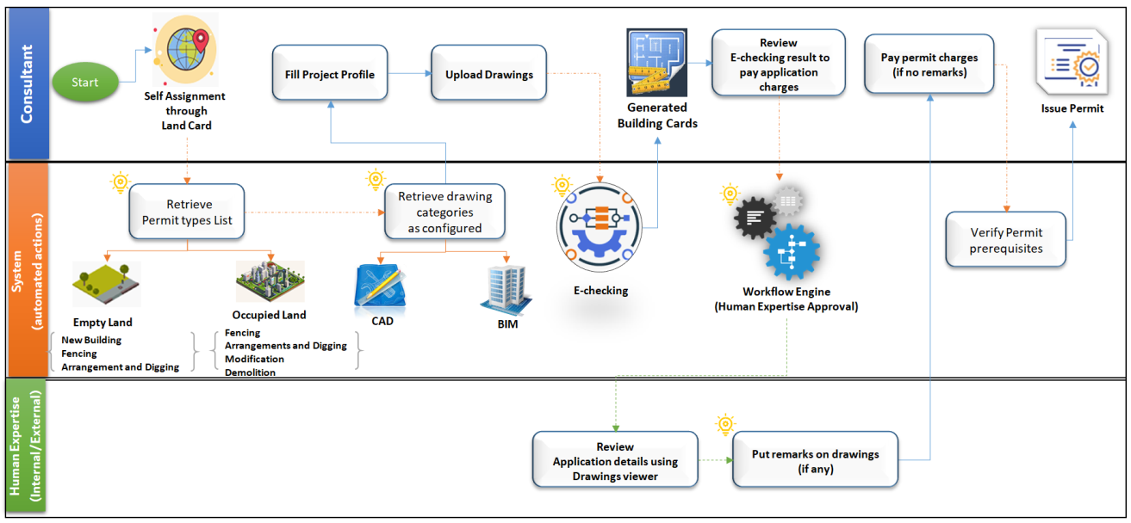

Building Permit Process flow

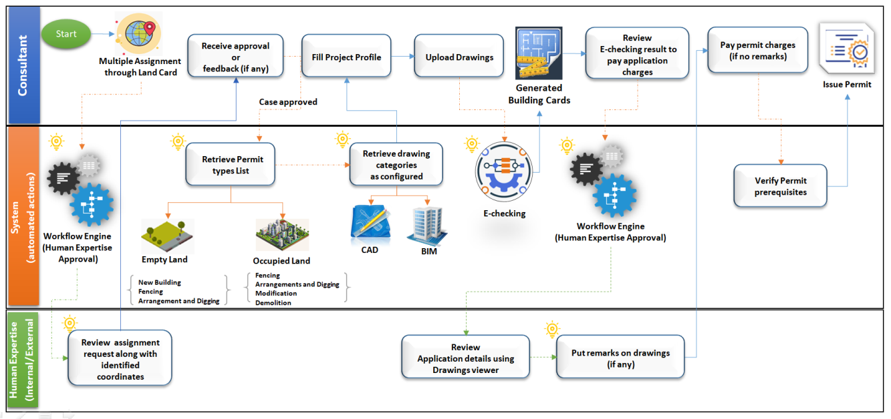

Building Permit Process flow- (in case of multiple consultants on same Land)

Once the applicant selects a certain land, and accepts legal responsibility, Terms and Conditions of self-assignment, the system automatically notifies Landowner(s) using *#Notification&Communication*.

According to Self-assignment, the applicant will be able to get prepared before applying for permit application through:

* Access all land information using *#Land Card*
* Define Project profile, identify permit type #*Project Profile*
* Design detailed drawing according to above findings.

Once the Drawings are prepared, the Applicant can apply for permit application as in the below steps:

**Step1:** **Upload drawings for each building**

The applicant will be able to add or select building for modification or demolition according to land status. For certain buildings, it is required to upload drawings only according to specified type and modification type, if any:

***Case CAD Drawings***: Upload the below categories in case of new building, or upload only categories changed in case of modification:

* Architectural Drawing
* Structure Drawings
* Mechanical Drawings
* Plumbing Drawings
* Electrical Drawings
* Water Supply Drawings
* Telecommunications Drawings
* Fire Detection, Alarm, Emergency Lighting, Fire Fighting
* Fire Life Safety Drawings
* Interior Drawings

***Case BIM***, Upload one model per building in case of new building or modification.

Once the building drawing(s) are uploaded, the system automatically verifies the drawing(s) against expected version using *#Archiving and document version control*, and alignment with DM regulation using *#E-Checking*through automated checklists configurable based on building type, usage, and permit type.

*#E-Checking* is also responsible for creating Building Card information from Building drawing(s) based on DM approved standards for building classified object and design guidelines (Layers) for both CAD and BIM Models.

Moreover, *#E-Checking* is also responsible for automatic verification on Drawings using configured checklists based on building types, usage and permit type

System will display the below to the applicant:

* + The automatic Generated building Card
  + The E- checking verification result with clear and detailed error messages. In case of error, identify what is the error and in which drawing file.

**Step2: Review Generated Building Card**

In this step, the applicant will be able to review the generated building card, and then go forward, either to add/modify another building or to go to **Step3***.*

Moreover, in case of any error returned from the *#E-Checking* verification with a clear and detailed errors identifying the error description and the drawing file containing the errors that will help the applicant to update the drawings and fix the error then re-upload them and the system will reevaluate the updated drawings and regenerate the correct building cards.

**Step3:** **Review Application Summary & Pay Application Fees**

Applicant will be able to view the application summary to make sure that there is nothing missed, and then proceed to payment.

In this step, the applicant will be able to view payment details identified by *#Dues Management* and select from the payment methods available using *#Integration* then pay.

**Step4:** **Review Application and Follow up remarks (If any )**

Once the voucher is paid, the system issues the permit immediately, or passes it for Human expertise verification level according to *#Digital Process Automation*, based on building type, usage, and permit type.

On Human expertise verification, the system will initiate task for each verification point, whether internal or external using *#Digital Process Automation* and *#Integration*.

These tasks will be handled and monitored by *#Task Management*, *#Staff Availability Monitoring*, *#Employee allocation and utilization* components.

Human Expertise will be able to verify their requests easily through:

* Consolidated Land Information
* Unified Building profile [Building Card, Drawing(s)]
* Drawings Viewers for both CAD and BIM

Moreover, they can request for a conference call with the applicant and staff using *#Appointments*, *#Scheduler management* components in case a clarification is required.

Based on the verification result, the applicant will be notified using *#Notification & Communication* to proceed for payment **Step5**.

**Step5:** **View and Pay Permit Fees**

Once the Applicant receives the notification of application approval, he/she will be able to view the permit fees payment details identified by *#Dues Management*, and select from the payment methods available using *#Integration* then pay.

Once the permit is issued, the system automatically issues Demarcation Visit Request using *#Integration*, so that the applicant can start work onsite.

##### Concept Design Approval

* Solution Brief

Introducing optional service to obtain NOC Concept Design without entries or documents, just upload drawings in few steps. In addition to *#E-checking* verification for the uploaded drawings on submission level through configurable checklists, based on permit type, building types, and usages to increase alignment with the DM regulations.

As the zone regulation specifies allowed usages for buildings, the Land status also specifies type of drawings and allowed permit types for this Land:

**Case Empty Land:** The applicant will have the flexibility to upload CAD or BIM drawings, and can apply for the below permit types:

* New Building

**Case Occupied Land**: Theapplicant will have to follow the same type of **As Built** drawing, and will be able to apply for the below permit types:

* Modification

Across various building types:

* Private Villa,
* Investment Villa,
* Industrial building,
* Public building,
* Multistory,
* Building service blocks.
* Actors
* Applicant (Consultant, Contractor)
* Smart Agent (System)
* Human Expertise (configurable whether internal or external Engineers)
* Product

NOC for Proposed Concept Design

* Prerequisites
* Applicant Self Assignment to the Land with acceptance to the Terms and Conditions of assignment.
* Design Drawings according to the approved standards by DM and using building classified object in addition to the design guidelines (layers) for each building.
* Define project profile with the permit type , building type and usages
* Terms and Conditions

Applicant cannot start work on Land.

* Channels

New Customer portal / New Employee portal

* Solution Details

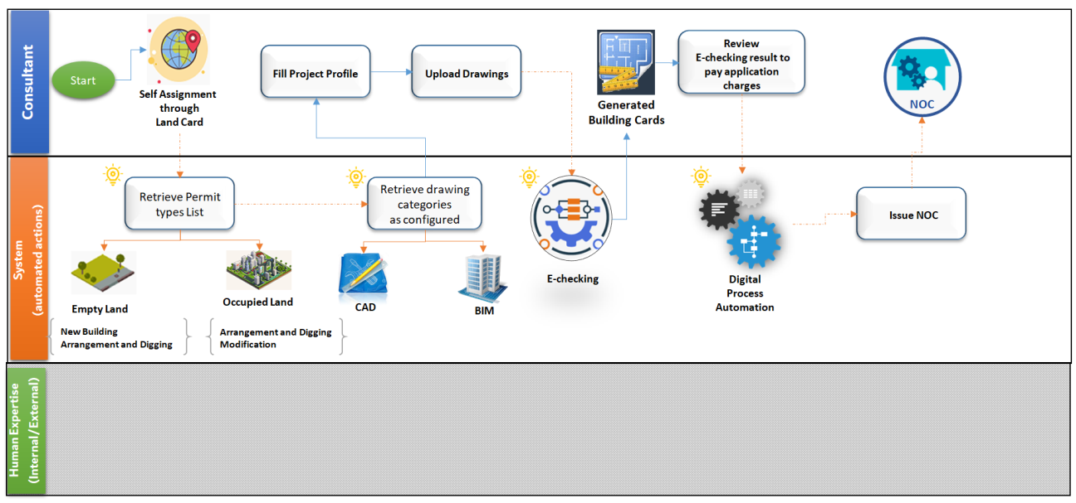

Concept Design Approval Process Flow

Once the applicant selects certain land, and approves on legal responsibility and terms and conditions of self-assignment, the system automatically notifies the Landowner(s) using *#Notification&Communication*.

According to Self-assignment, the applicant will be able to get prepared before applying for the NOC Concept Design through:

* Access all land information using *#Land Card*
* Define Project profile, identify application type #*Project Profile*
* Design detailed drawing according to above findings.

Once the Drawings are prepared, the applicant can apply for the NOC Concept Design application through the below steps:

**Step1:** **Upload Drawings for each Building**

The applicant will be able to add or select building for modification according to land status; it is required to upload drawings only based on specified building type and modification type.

***Case CAD Drawings***, Upload below categories in case of new building, or upload only categories changed in case of modification:

* Electrical Drawings
* Water Supply Drawings
* Telecommunications Drawings

***Case BIM***, Upload one model per building in case of new building or modification.

Once the building drawing(s) are uploaded, the system automatically verifies the drawing(s) against expected version using *#Archiving and document version control*, and alignment with DM regulation using *#E-Checking*through automated checklists configurable based on building type, usage, and permit type on the scope of Concept Design Approval.

*#E-Checking* is also responsible for creating Building Card information from Building drawing(s) based on DM approved standards for building classified object and design guidelines (Layers) for both CAD and BIM Models that configured for Concept Design Approval service.

Moreover, *#E-Checking* is also responsible for automatic verification on Drawings using configured checklists based on building types, usage and permit type.

The system will display the below to the applicant:

* + The automatic Generated building Card
  + The E- checking verification result with clear and detailed error messages. In case of error, identify what is the error and in which drawing file.

**Step2: Review Generated Building Card**

In this step, the applicant will be able to review the generated building card, then go forward, either to add/modify another building or go to **Step3**.

Moreover, in case of any error returned from the *#E-Checking* verification with a clear and detailed errors identifying the error description and the drawing file containing the errors that will help the applicant to update the drawings and fix the error then re-upload them, and the system will reevaluate the updated drawings and regenerate the correct building cards.

**Step3:** **Review Application Summary & Pay Application Fees**

Applicant will be able to view the application summary to make sure that there is nothing missed, and then proceed to payment.

In this step, the applicant will be able to view payment details identified by *#Dues Management* and select from the payment methods available using *#Integration*, then pay.

**Step4:** **Issue the NOC**

Once the voucher is paid, the system issues the NOC immediately based on *#E-Checking* throughthe DM/NOC’s checklists to verify the application automatically without consuming human expertise capacity or effort in such service.

### Supporting Services

##### Building Exception

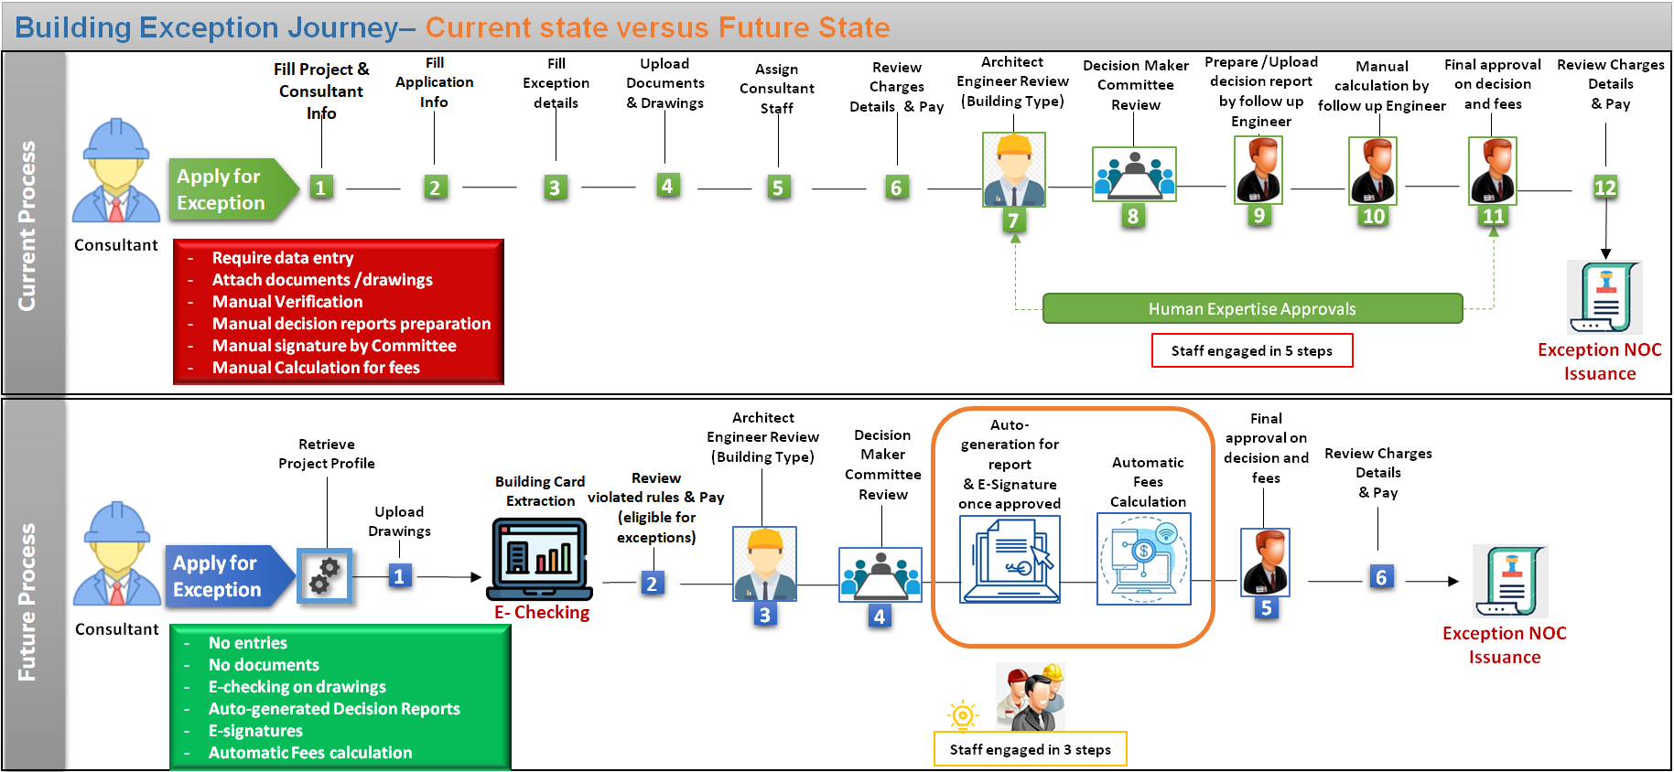

**Building Exception Journey– Current State versus Future State**

* Solution Brief

Introducing service to obtain an exception to carry out some of the building construction work that does not meet configured regulations, within acceptable standards or technical configured requirements.

* Actors
* Applicant (Consultant, Contractor or Owner)
* Smart Agent (System)
* Human Expertise (configurable whether internal or external Engineers)
* Product

Approved Building exception.

* Prerequisites
* Applicant Self-Assignment to the Land.
* Provide required drawings based on the approved standards by DM and using building classified object in addition to the design guidelines (layers) for each building.
* Define project profile with the permit type, building type, usages and exception details.
* Terms and conditions

Applicant will not be able to use this exception more than once.

* Channels

New Customer portal / New Employee portal

* Solution Details

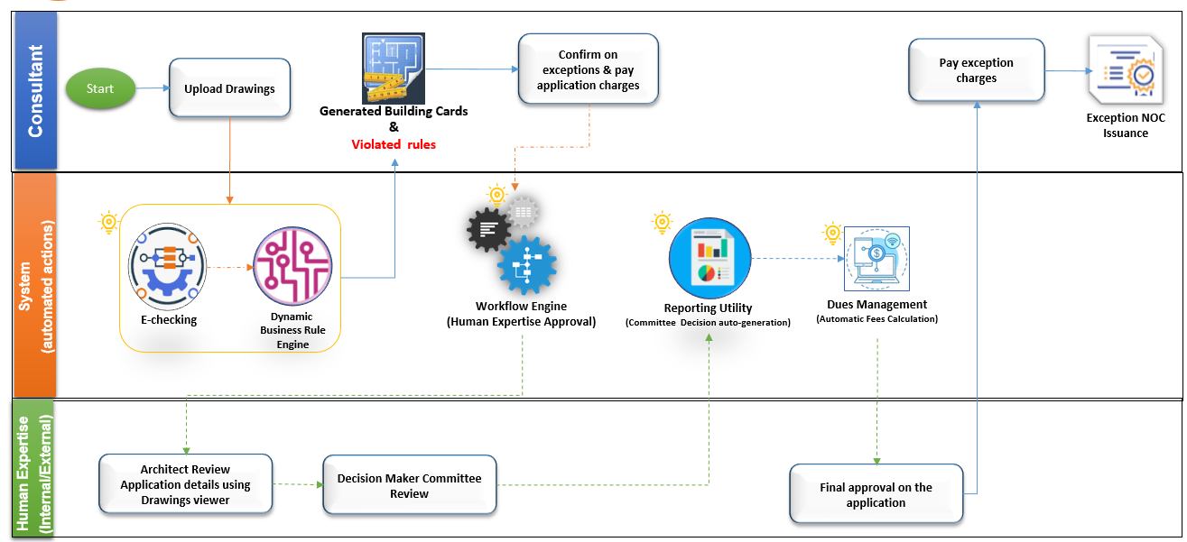

Building Exception Process Flow

Once the applicant applies for exception, the system automatically will retrieve the exception information entered in the project profile earlier.

Exception application can be applied separately or within the permit application.

**Case1: Exception applied separately**

**Step1: Upload Drawings**

Applicant will upload the required drawings (CAD or BIM) related to the exception type/sub type specified in project profile.

***Case CAD Drawings***, Upload the below categories:

* Architectural
* Electrical
* Fire Protection
* Interiors
* Mechanical
* Plumbing
* Structural
* Survey/Mapping

***Case BIM***, Upload one model per building

Once the drawing(s) are uploaded, the system automatically verifies the drawing(s) against:

* Expected version using *#Archiving and document version control*,
* The alignment with DM regulation using *#E-Checking*through the automated checklists which are configured based on building type, usage and service type considering that there is no violated rules rather than the specified exception types in project profile.

**Step2:** **Review Request summery and pay application fees**

Once the information are extracted and the E-Checking verification result is displayed along with exception summary, the applicant will review details and view application charges and expected exception fees, which will be calculated automatically by *#Dues Management* to make sure that the applicant is aware of exception fees in case of approval.

Then the applicant will select from the payment methods available using *#Integration* to pay the application fees.

**Step3:** **Exception Review (Level1) by** Architect Engineer

According to *#Dynamic Business process*, the system routes the request to the human expertise concerned with this type of applications (Architect Engineer) considering building type and Exception type.

The Architect Engineer reviews the application details and add feedback to be presented to the Committee of Exception to take the decision **Step4**

**Step4:** **Decision Maker Committee Review (Level2)**

Once the Architect engineer adds feedback, the system will automatically generate the report that include the following information to be reviewed by the Committee and help them take the decision:

* Exception Details
* Architect engineer Feed back
* Uploaded drawings in viewers

Once the Committee takes the decision and confirms it, the system will automatically apply electronic signature on the generated report along with approved decision then *#Dues Management* will directly calculate the exception fees based on the configured equations according to exception type and the calculated area for the exception, in addition to the Land Price which will be evaluated based on below information retrieved though *#Integration*:

* **Case Land not rented**; the latest active evaluation/pricing certificate from Land department (issue new request if none).
* **Case Land rented**; the contract information from RERA (contract value)

**Step5:** **Final approval on decision and fees (Level 3)**

Once the Exception fees are calculated by the system automatically, the request will be routed to next level of approval based on configuration through *#Dynamic Business process* to review final Decision and Fees.

Moreover, all Verification tasks will be handled and monitored by *#Task Management*, *#Staff Availability Monitoring*, *#Employee allocation and utilization* components.

**Step6:** **Pay Exception Fees**

In this step, the applicant will be notified with final decision and can also view the payment details and select from the available payment methods using *#Integration*, and then pay in case of approval.

Once the voucher is paid, the system issues exception E-certificate immediately, and the applicant can use it according to DM regulations.

In case the Applicant did not use the exception and want to cancel it, the system will automatically use the *#Integration* with **Finance Department** to make Electronic Refund with the approved percentage of exception fees in case on cancellation approved from DM.

**Case2: Exception applied within building permit application:**

**Step1: Upload Drawings**

The applicant will upload the drawings for each building as same as Demonstrated in the *#Building Permit Service*.

Once the drawing(s) are uploaded, the system automatically verifies the drawing(s) against:

* Expected version using *#Archiving and document version control*,
* The alignment with DM regulation using *#E-Checking*through the automated checklists which are configured based on building type, usage and service type considering that there is no violated rules rather than the specified exception types in project profile.

And *#E-Checking*will also generate building cards.

**Step2:** **Review Request summery and pay application fees**

Once the information are extracted and the E-Checking verification result is displayed along with exception summary, the applicant will review details and view application charges and expected exception fees which will be calculated automatically by *#Dues Management* to make sure that the applicant is aware of exception fees in case of approval.

Then the applicant will select from the available payment methods using *#Integration* to pay the application fees.

**Step3:** **Application Review**

According to *#Dynamic Business process*, the system routes the request to the human expertise concerned with both *#Building Permit Service* and *#Building Exception Service* as same as demonstrated before in **Step4** and **Step5** but parallelly.

**Step6:** **Pay Exception Fees**

In this step, the applicant will be notified with final decision and can also view the payment details for both Permit and related exception, then select from the available payment methods using *#Integration*, to pay in case of approval.

Once the voucher is paid, the system issues permit E-certificate along with related exception and the applicant can use it according to DM regulations.

##### Land Procedures

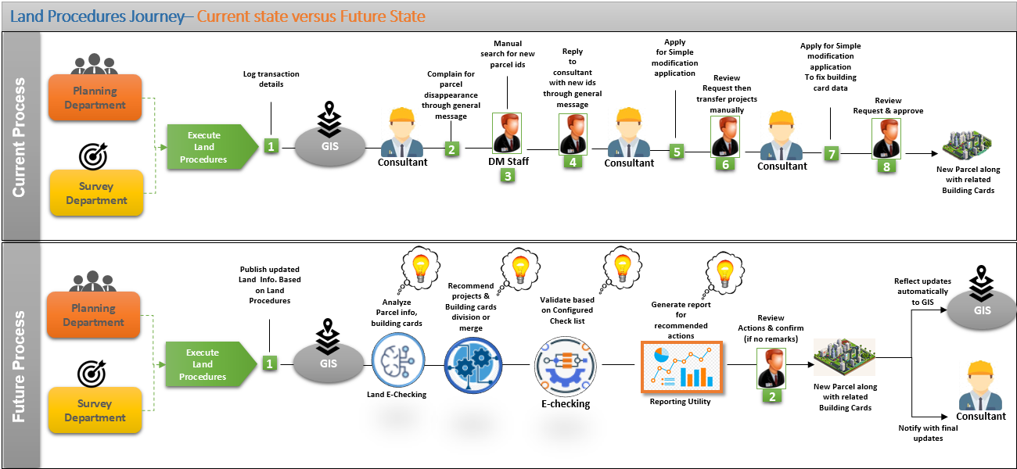

**Land Procedure Journey– Current State versus Future State**

* Solution Brief

Introduce automated process in which Lands information will be updated automatically based on published land procedures (split, merge or change coordinates) that have been executed in Planning and Survey department systems. This process will be triggered automatically using #Integration between GIS and internal departments (Planning, and Demarcation departments). Based on analyzing current and new status and information of the impacted lands using #BI & Data Analysis, the system will recommend required actions to apply published procedure on the targeted lands/Projects and Buildings, along with recommended corrective actions that should be resolved by the Consultant if any.

This automation will be applied for both non-vacant and under construction Lands.

* Actors
* Smart Agent (System)
* Permit Engineer
* Product
* Land procedures accomplished
* Land information updated accordingly
* Prerequisites

Land procedure request triggered by planning and demarcation departments for non-vacant or under construction Lands.

* Channels

New Employee portal

* Solution Details

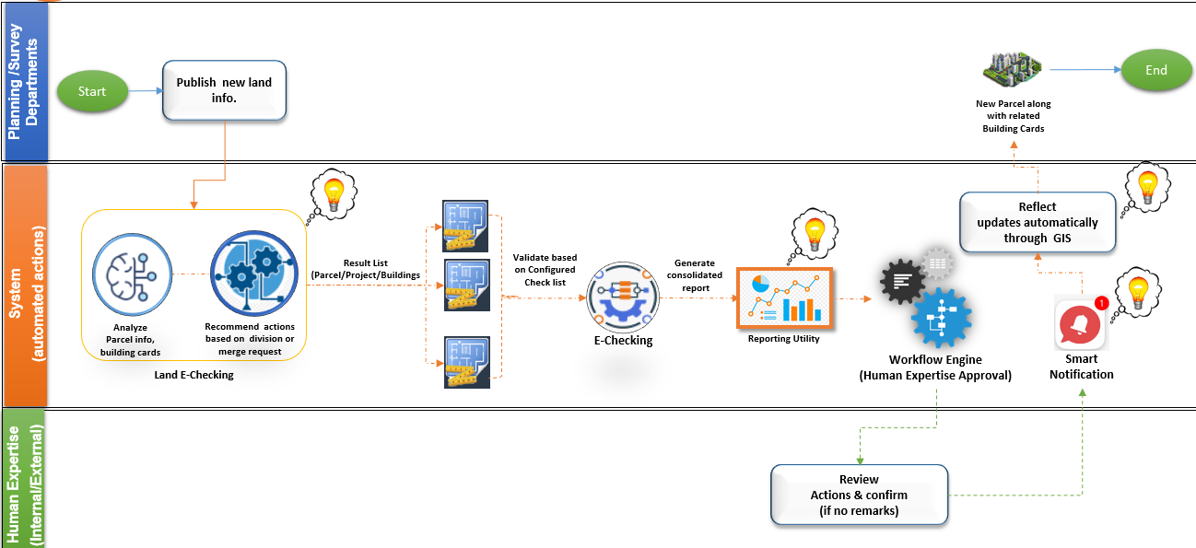

Land Procedures Process Flow

***Step1: Receive Land Procedure Request***

The system will receive published Land procedure from Planning and Demarcation departments through the integration between them and GIS using #Integration.

Accordingly, the system will analyze the below information (current land status/info and the new changes) using #Land E-Checking:

* Land information,
* Land affection plans,
* Plot coordinates,
* Impacted projects,
* Unified buildings profiles (building card and drawings)

Based on the #Land E-Checking , the system will decide projects/buildings reallocation. Then, the system will assist buildings profiles (building card, drawings) against new land regulations and recommend corrective actions that should be resolved by the Consultant - if any - based on #E-Checking.

As a result, the system will generate consolidated report of all decided actions required to reflect published land procedure using *#Reporting Utility* to be reviewed and verified by relevant Staff, as configured for this procedure using *#Dynamic Business process*.

Verification tasks will be handled and monitored by *#Task Management*, *#Staff Availability Monitoring*, *#Employee allocation and utilization* components.

***Step2: Review Actions and Confirm (if no Remarks).***

Staff will be able to review and modify recommended actions demonstrated in the consolidated report if needed.

Once the request is confirmed, thesystemautomatically notifies all relevant authorities and Landowner(s)/assigned consultants with the approved actions using *#Notification&Communication*.

Approved Land information updates will be published automatically to GIS to be shared with relevant internal and external authorities as per their accessibility.

In case of corrective actions required from the Consultant side, the permit will remain on hold till all required actions applied by the consultant and verified from Permit section within configured grace period approved by the Permit section.

**Innovation idea:** The above-automated process can be used as reconciliation procedure that will be executed automatically/periodically at the backend to ensure the continuous integrity of data based on continuous updates applied through the system and also received from internal or external authorities through GIS.

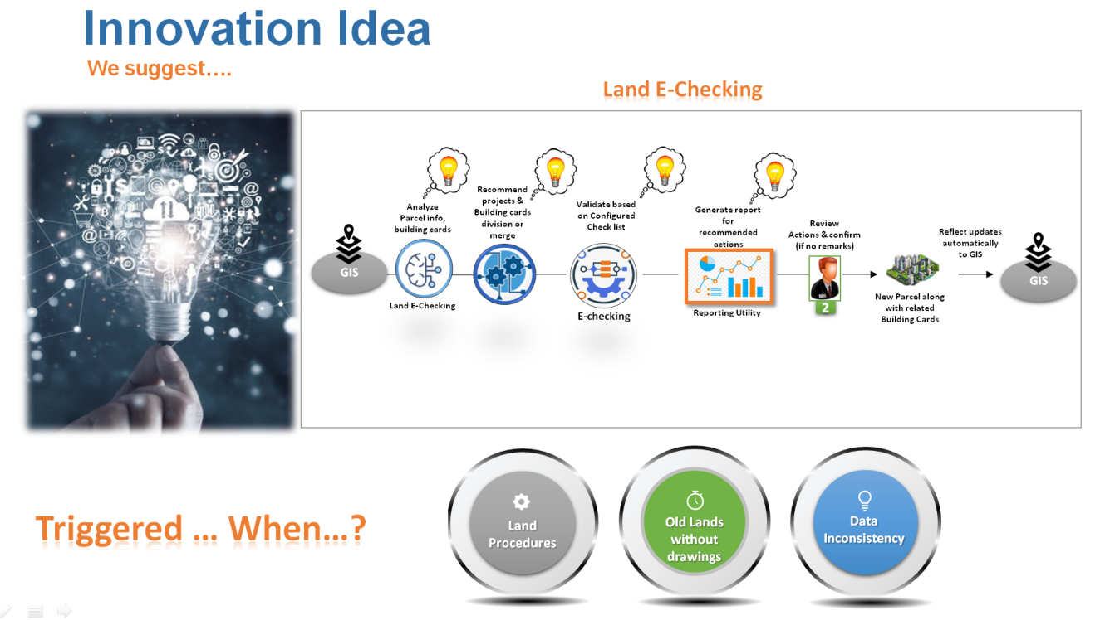

Innovation idea- Reconciliation Procedure

# Dependencies

To fulfill all the proposed solutions which are listed in this document, The Dubai Municipality and its representative must supply thereunder data on design phase:

* Building Card attributes & relatives checklist per building type, usage and service type
* Approved Exception types & subtypes List
* Approved Building usages per Building type
* CAD drawing categories per permit type based on approved design standards
* Charges and fees calculation per service type
* Services SLA and Staff KPIs

# Risks

* Changes in law, regulations, or current system during analysis activities.
* Readiness of internal or external Authorities systems and resistance for new integration facilities and agreements.
* Cooperation of internal and external authorities to provide their validation checklists classified according to application and building type and its severe impact on transactions duration and number of steps.
* Continuous changes applied to the current business process and current system.
* Level of information that can be extracted from Approved Drawing template [CAD or BIM] and its major impact on automation of Building card generations.

# Assumption

The Dubai Municipality and its representative, GIS Team, pledge to provide all the documents required by ISoft in order to complete the system design phase

# Appendices

## References

* Building-Regulations



* The local order number 3 for the year 1999



* Dealing with Construction Permits



* Comparison of building permit procedures in European Union Countries



* How Does China Achieve a 95% Compliance Rate for Building Energy Codes
* 

## Survey Result

|  |  |  |  |  |
| --- | --- | --- | --- | --- |
| **Question** | **Pain** | **Solution** | **BRS Section** | **Raised by** |
| **What do you expect from the new system?** | Consolidated file for all regulations | Through Land Card based on GEO consolidated hub | 2.3.1.1 Core Components - Land Card | Consultant |
| Simple, easy to track and search for projects | Personalized dashboards along with interactive maps for lands/projects | 2.2 Smart Modules – Dynamic Dashboard |
| Service utilities info and entries for the land DEWA, RTA, etc. | Through Land Card/services utilities section based on GEO consolidated hub | 2.3.1.1 Core Components - Land Card |
| Work with REVIT | Through E-checking engine CAD/BIM standards can be configured along with related checklists and mapped to building cards fields that will be extracted automatically from drawings based on building type, usage, and permit type. | 2.2 Smart Modules – E- Checking |
| Ease to use in both smart device and desktop, and Friendlier UI | Responsive, simple and seamless design through which each user will have personalized dashboard, direct access to services without attachments without entries along with interactive maps for lands/projects | 2 Business Process Overview  2.2 Smart Modules – Dynamic Dashboard | Contractor |
| Unified projects have access for all services in Completion application |
| **Do you normally need to visit DM premises?** | Follow up for my application | Personalized dashboard enables seamless tracking for submitted requests and direct access to authorized services | 2.2 Smart Modules – Dynamic Dashboard | Consultant |
| Discuss with unit head in some cases | Based on KPI engine, the Unit head will be able to monitor engineers’ performance easily and take corrective actions if required proactively | 2.2 Smart Modules – KPIs Evaluation & Monitoring |
| Direct communication is better and faster to resolve old building card info | Using Land E-checking automated procedure, such cases will be detected, analyzed, and resolved before facing the Consultant | Innovation Idea of Land E-checking |
| Resolve Special problem such as authority transfer from DM to DDA | Based on proposed integration with permitting authorities, there is no need for consultant intervention | GEO Consolidated Information Hub |
| **Do you normally need to visit other authority’s premises?** | DCD, Etisalat, RTA all don't have online communications, and Approval take too much time | Fast track inquiry component will facilitate on-spot inquires | 2.3.1.1 Core Component – Fast track Inquiry | Consultant & Contractor |
| Follow up and direct discussion regarding my application feedback and inquiries | Using appointment module, the consultant will have seamless communication with staff based on configured capacity and availability | 2.2 Smart Modules – Appointment |
| **How Many attempts to Issue permit, Resubmit application & drawings approval?** | Unclear or incomplete comments | E-Checking Verification on submission level through configured, structured checklists, in addition to Staff remarks on drawings using viewers | 2.2 Smart Modules – E- Checking | Consultant & Contractor |
| Short duration for approval, for example: CFR approval (3 days) | Smart Appointments | 2.2 Smart Modules – Appointment | Consultant |
| Different points of view between Designer and DM Engineer | Will be resolved through approved design guidelines and standards from DM, in addition to Smart Appointments | 2.2 Smart Modules – E- Checking  2.2 Smart Modules – Appointment |
| Owner requirements do not match with DM Rules | E-Checking Verification with increase alignment with DM regulation on submission level 24/7 | 2.2 Smart Modules – E- Checking |
| **Do you have any additional problems you may highlight on the current system?** | Online appointments, Online booking | Smart Appointments Module with seamless facilities for booking, rescheduling, and sharing demonstrated materials | 2.2 Smart Modules – Appointment |
| Building Card improvement and removal of unnecessary options | Building card information will be improved and enhanced based on the approved design standards from DM  Through E-checking engine, Building Cards will be automatically extracted from drawings based on configured mapping | 2.2 Smart Modules – E- Checking |
| Improve speed of system approvals from DEWA and DCD | Using Direct integration with concerned authorities DEWA, DCD, etc.  Additionally, advancing Payment facilities through ERAD | GEO Consolidated Information Hub |
| The appointment evaluation page should pop up after the appointment ends | Using KPI engine, Staff interaction with customer /requests will be tracked, and evaluated | 2.2 Smart Modules – KPIs Evaluation & Monitoring |
| Automatic submission to Application fees after Payment done  Engage all concerned authorities in permit process | Using Dynamic WF engine, the system will automatically route the request to payment or verification tasks, based on advanced integration facilities with ERAD and integration with internal/external authorities | 2.2 Smart Modules – Digital Process Automation  2.2 Smart Modules – Dues Management |
| Enhance usability to download all stamped drawings together | Click on Land Card to download all stamped drawings, no need for service | 2.3.1.1 Core Components - Land Card |
| Filling up the DEWA form in the services of every application | All required information will be extracted from the uploaded drawings according to the approved design standards from DM, and no entries will be required | 2.2 Smart Modules – E- Checking |
| Owner, Consultant, and plot data can be extracted from project information | All land information gathered from internal/external authorities will be accessible by the owner, the assigned consultant or the contractor, based on configured privileged approved by DM, and no need to apply for any application to gather these information | 2.3.1.1 Core Components - Land Card  2.2 Smart Modules – Customer Management |
| Application for Gate level if submitting as 2nd version | 2.3.1.1 Core Components - Land Card |
| Services are so many, and searching and selecting the required service is difficult | Through personalized dashboard, the applicant will have direct access to services for which s/he is authorized  Additionally, permit services have been merged into 3 services which will make it easier for applicant to apply for. | 2 Business Process Overview  2.2 Smart Modules – Dynamic Dashboard  2.3.1.1 Core Components – Project Profile |
| Categorize the Engineers’ remarks to mandatory for issue permit and mandatory to start work with permit | Permit will be verified through E-Checking Verification on submission level through configured, structured checklists, in addition to Staff remarks on drawings using viewers | 2.2 Smart Modules – E- Checking |
| Based on KPI engine, the Unit head will be able to monitor engineers’ performance easily and take corrective actions if required proactively | 2.2 Smart Modules – KPIs Evaluation & Monitoring | Consultant |
| We encounter Building Card issues for GSM Tower projects, and our contractor is under Ground only, and G+ 1 cannot be directly appointed in the system | Through direct integration with prequalification system (DEQ), contractors will be easily appointed based on their qualification and approved exceptions if any | GEO Consolidated Information Hub | Consultant |
| For DEWA Electricity, we need to know the progress of submission | Through the integration with concerned internal and external authorities, request approvals will be tracked automatically, and applicant can trace it easily through his/her own dashboard | GEO Consolidated Information Hub  2.2 Smart Modules – Dynamic Dashboard | Contractor |
| Unify Payment Options | Seamless payment/refund through advancing integration facilities with ERAD | GEO Consolidated Information Hub |
| We cannot search in building Permits’ notification messages | Through personalized dashboards, the Applicant will be able to access, filter, and view his/her own notifications | 2.2 Smart modules - Notification & Communication | Contractor |
| System is not compatible with Apple devices, and DWF files can be opened only on windows devices | Based on published Design standards for CAD or BIM, there will be no such limitations using E-checking engine | 2.2 Smart Modules – E- Checking  2.2 Smart Modules – BIM | Contractor |
|  | We need to add customer service for building permit section | Through Chabot, the system will respond instantly on the customers’ enquiries without involving the customer support engineer for the FAQ questions and saved topics.  This is in addition to smart appointment module for advanced clarification regarding specific request.  The transactions/actions accomplished using general message have been automated into services/digital procedures | 2 Business Process Overview  2.2 Smart modules – Chatbot  2.2 Smart Modules – Appointments | Contractor |
| Communication and support through general messages and assigning different users and responsibilities is a bit confusing. | Contractor |
| **Do you suggest adding any other authorities to the new system?** | Direct Contact with engineers of DEWA and RTA & police Department | According to Appointments module and integration with these authorities, the communication will be faster and simpler | GEO Consolidated Information Hub  2.2 Smart Modules – Appointments | Consultant & Contractor |
| Other Building Permits authorities | According to Integration with GIS, the system will be able to communicate with the other Building permits authorities like (TARAKHES, Free Zone, etc.) |
| **Please select the payment methods you usually use to pay in the current system and problem Faced** | Do not get a receipt for most of the time, and payment of fees option is not very user-friendly. | Seamless payment/refund through advancing integration facilities with ERAD in addition to the personalized dashboard enabling easily tracking for submitted requests and direct access to authorized services | GEO Consolidated Information Hub  2.2 Smart Modules - Dynamic Dashboard | Consultant & Contractor |
| In some cases, when paying a large amount of money, there is no information to link the payment with the application |  | Consultant & Contractor |
| **Please select methods that you find effective to improve the system.** | Improve Customer service to help the applicant while applying for services | * Through Chabot, the system will respond instantly on the customers’ inquiries without involving the customer support engineer for the FAQ questions and saved topics. * Smart Appointment module for advanced clarification regarding a specific request. * Personalized dashboard enabling easily tracking for submitted requests and direct access to authorized services * Permit services have been merged in to 3 services which will make it easier for applicant to apply for. | 2.2 Smart modules – Chatbot | Contractor |
| Please make it easier to manage draft applications, like adding a shortcut to the home page or dashboard | 2.2 Smart Modules - Dynamic Dashboard |
| Have a simpler system for drawing approval, like for retail shops and offices decor works, the process and steps can be dealt with separately | 2.3.1.2 Core Services – Building Permit |